# INDUSTRIAL PARAMETERS MONITORING USING WIFI MODULE

PROJECT REPORT SUBMITTED TO

**VEER SURENDRA SAI UNIVERSITY OF TECHNOLOGY BURLA, ODISHA**

In the partial fulfilment of the requirements for the award of degree of

**Bachelor of Technology in**

**ELECTRONICS AND TELECOMMUNICATION ENGINEERING**



Submitted By:

Dibya Ranjan Sahu (1702070039)

Chinnari Likhita (1702070038)

Maamim Sheikh (170207059)

Under the Guidance of:

**MR. ADITYA KUMAR HOTA**

(Assistant Professor)

**DEPARTMENT OF ELECTRONICS AND TELECOMMUNICATION ENGINEERING**

**VEER SURENDRA SAI UNIVERSITY OF TECHNOLOGY, BURLA MAY-2021**



DEPARTMENT OF ELECTRONICS AND TELECOMMUNICATION ENGINEERING VEER SURENDRA SAI UNIVERSITY OF TECHNOLOGY

BURLA, SAMBALPUR, ODISHA-768018

**CERTIFICATE**

This is to certify that the project report entitled “**INDUSTRIAL PARAMETERS MONITORING USING WIFI MODULE**” presented by Dibya Ranjan Sahu (1702070039), Chinnari Likhita (1702070038), Maamim Sheikh (1702070059) in VSSUT, Burla under the guidance of **Mr. Aditya Kumar Hota**, Assistant Professor, Department of Electronics and Telecommunication Engineering. This is in partial fulfilment of requirement of project report for BACHELOR OF TECHNOLOGY DEGREE IN ELECTRONICS AND TELECOMMUNICATION ENGINEERING in VSSUT, BURLA. This is a bonafide work carried out by them and no part of this project work has been submitted to any other university or institution for the award of any degree or otherwise to the best of my knowledge.

**DR. KABIRAJ SETHI MR. ADITYA KUMAR HOTA**

Head of the Department Assistant Professor

Department of Electronics Department of Electronics

and Telecommunication and Telecommunication

VSSUT, Burla VSSUT, Burla



VEER SURENDRA SAI UNIVERSITY OF TECHNOLOGY BURLA, SAMBALPUR, ODISHA-768018

## CERTIFICATE OF APPROVAL

This project report entitled, “**INDUSTRIAL PARAMETERS MONITORING USING WIFI MODULE**” submitted by Dibya Ranjan Sahu (1702070039), Chinnari Likhita (1702070038), Maamim Sheikh (1702070059) to the Department of Electronics and Telecommunication Engineering, Veer Surendra Sai University of Technology, Burla, Odisha has been examined by us. It is found fit and approved for the degree of Bachelor of Technology.

**INTERNAL EXAMINER EXTERNAL EXAMINER**

**ACKNOWLEDGEMENT**

We are immensely grateful to Dr. Kabiraj Sethi, Associate Professor, H.O.D, Department of Electronics and Telecommunication Engineering and Mr. Aditya Kumar Hota, Assistant Professor, Department of Electronics and Telecommunication Engineering, for their kind support and guidance without which this project could not have been materialized. Their motivating and inspiring insights has guided our thinking throughout our work and to improve the results in our work.

This project is a product of the hard work and collective efforts of all the members of the group who had been constantly encouraging each other throughout the project.

We would also like to thank the society of Electronics and Telecommunication Engineering for giving us this opportunity to work together as a team on this project as a part of our curriculum.

**DECLARATION**

We hereby declare that the project report entitled, “**INDUSTRIAL PARAMETERS MONITORING USING WIFI MODULE**” submitted by us to the Department of Electronics and Telecommunication Engineering, VSSUT is a record of the project work done by us under the guidance of Mr. Aditya Kumar Hota and the project report is submitted in the partial fulfilment of the requirement for award of Bachelor’s degree from Veer Surendra Sai University of Technology, Burla. We further declare that this report will not be submitted, either in part or in full to any other institution or university.

**DIBYA RANJAN SAHU (1702070039)**

**CHINNARI LIKHITA (1702070038)**

**MAAMIM SHEIKH (1702070059)**

**TABLE OF CONTENTS**

|  |  |  |
| --- | --- | --- |
| CHAPTER NO. | TITLE | PAGE NO. |

|  |  |  |
| --- | --- | --- |
| 1. | ABSTRACT | 6 |
| 2. | INTRODUCTION | 7 |
| 3. | HARDWARE  REQUIREMENTS | 8-12 |
| 4. | FLOWCHART | 13-14 |
| 5. | CIRCUIT AND WORKING | 15-19 |
| 6. | RESULTS | 20-21 |
| 7. | APPLICATIONS | 22 |
| 8. | LIMITATIONS | 23 |
| 9. | CONCLUSION AND  FUTURE SCOPE | 24 |
| 10. | REFERENCES | 25 |

**ABSTRACT**

Despite of security in plants, industrial environment is still dangerous for human and machines. This project deals with safety in industrial condition. It presents a prototype of implementation of an automated system that uses Wi-fi Technology and various sensors which monitors and can help in controlling several parameters used in industrial applications such as Smoke, Light, Temperature. The various parameters can be accessed and monitored from remote area by cloud computing and notifications about any abnormal conditions can be automatically sent to a computer or smartphone. Here, Arduino Uno is adopted as the core controller. By detecting the values of sensors, it can easily find out the temperature, Smoke, Light and Gas levels in industries and controls the parameters if any abnormalities are observed. So, the critical situation can be avoided by sending alert messages and notifications to respective in-charge and preventive measures can be successfully implemented. It is a simple smart monitoring and security system and also tells the importance of IoT in industrial applications. It is the most effective and most economical means of equipment safety monitoring. .

**INTRODUCTION**

Now- a – days, the industrial monitoring field requires more manual power to monitor and control the industrial parameters such as temperature, humidity, gas etc. This is one of the most commonly observed issues in the industrial sectors. If the parameters are not monitored properly, it leads to a harmful situation. Most of the industries are facing those kinds of situation because of some manual mistakes. In order to avoid these mistakes, we made an automated monitoring system based on IoT using Arduino UNO and NodeMCU. IoT being the trending and which monitors parameters like temperature, gas, light in the industries and informs immediately if any of these parameters have reached to levels that could cause harmful damage. The core controller adopted here is Arduino UNO. The values from the sensors are sent to the controllers which then sends alert messages and emails via NodeMCU.

**HARDWARE REQUIREMENTS**

**Node MCU**: The NodeMCU (***N***ode ***M***icro***C***ontroller ***U***nit) is an open-source software and hardware development environment built around an inexpensive System-on-a-Chip (SoC) called the ESP8266. The ESP8266, designed and manufactured by Espressif Systems, contains the crucial elements of a computer: CPU, RAM, networking (Wi-Fi), and even a modern operating system and SDK. That makes it an excellent choice for the Internet of Things (IoT) projects of all kinds.

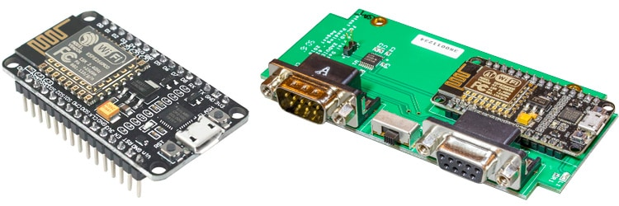

**NodeMcu ESP8266 CP2102 WIFI Development Board**

The board is based on the highly popular ESP8266 Wi-Fi Module chip with the ESP-12 SMD footprint. This Wi-Fi development board already embeds in its board all the necessary components for the ESP8266 (ESP-12E) to program and upload code. It has a built-in USB to serial chip upload codes, 3.3V regulator and logic level converter circuit so you can immediately upload codes and connect your circuits. This board contains the ESP-12E chip with a 4MB flash memory.

The ESP8266 NodeMCU with cp2102 development board - a true plug-and-play solution for inexpensive projects using Wi-Fi. The module arrives pre-flashed with NodeMCU firmware so just install your USB driver. The NodeMCU is an open-source project and you can find all the design files and so on from their GitHub page. This microcontroller board can easily be programmed using the Arduino IDE programming software.

**Specifications: -**

* Microcontroller - ESP-8266 32-bit
* NodeMcu Model - Amica
* NodeMCU size - 49mm x 26mm
* Pin Spacing - 0.9" (22.86mm)
* Clock Speed – 80 MHz
* USB to Serial – CP2102
* USB Connector – Micro USB
* Input Voltage – 4.5V to 10V
* Analog Pins – 1
* Digital I/O Pins – 11
* UART/SPI/12C -1/1/1
* ADC Range – 0.3-3V
* Flash Memory/SRAM – 4MB / 64KB
* Wi-Fi Built-In – 802.11 b/g/n
* Temperature Range - -40C – 125C

**NTC Thermistor Temperature Sensor Module: -**

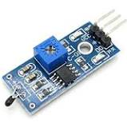

**Thermistor**is an electronic component used to calculate the temperature. This is a type of resistor whose resistance varies with change in temperature. These NTC thermistors are made up from the combination of metal oxides which passed through sintering process which gives negative electrical resistance versus temperature (R/T) relationship to it. Due to having a large negative slope a small change in temperature cause a huge change in electrical resistance.

Basically, there are two **types of thermistor** one is **NTC**(**Negative Temperature Coefficient**) and second one is **PTC**(**Positive Temperature Coefficient**). If the thermistor is NTC type then it decreases the resistance as increase in temperature and PTC behaviour is just opposite to the NTC. A thermistor is connected with any electrical circuit to measure the temperature of the body or the substance. This thermistor’s operating temperature range is -55 °C to 125 °C, the range of the temperature depends upon the base resistance.

**Specifications: -**

* Resistance at 25 °C - 10K + - 1%
* B-value (material constant) - 3950+- 1%
* Dissipation factor - approx.7.5mW/K(air)
* Thermal cooling time constant - <=20 seconds(air)
* Thermistor temperature range - -55 to 125°C

**LM393 Photosensitive LDR Sensor Module**

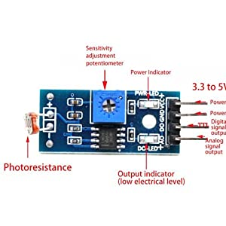

This LM393 Photosensitive Light-Dependent Control Sensor Module is using a high-quality LM393 voltage comparator. Easy to install using the sensitive type photosensitive resistance sensor the comparator output signal gives a clean and good waveform. Driving ability is 15mA with the adjustable potentiometer, it can adjust the brightness of the light detected. Working voltage is 3. 3V to 5v. Where output is digital switch output. Since this module is sensitive to the light, usually used for detecting the ambient brightness and light intensity. When there is no light or the light intensity cannot reach the value, DO output is high level. When light intensity over than the value, the module DO output is low level. The module digital output DO can be directly connected to the micro-controller, use micro-controller detects high or low level, so that can detect the environmental light intensity change.

**Specifications: -**

* Operating Voltage – 3.3V to 5V DC
* Operating Current - 15mA
* Output Digital – 0V to 5V
* Output Analog – 0V to 5V

**MQ-2 Smoke/LPG/CO Gas Sensor Module: -**

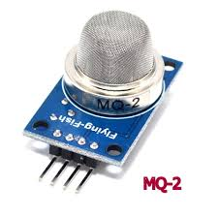

The MQ-2 Gas sensor can detect or measure gasses like LPG, Alcohol, Propane, Hydrogen, CO and even methane. The module version of this sensor comes with a Digital Pin which makes this sensor to operate even without a microcontroller and that comes in handy when you are only trying to detect one particular gas. When it comes to measuring the gas in ppm the analog pin has to be used, the analog pin also TTL driven and works on 5V and hence can be used with most common microcontrollers.

**Specifications: -**

* Operating Voltage – 5V
* Analog output voltage - 0V to 5V
* Digital Output Voltage - 0V or 5V (TTL Logic)
* Dimension (mm) - 32 (L) x 22 (W) x 27 (H)
* Weight – 10g
* Detects or measure Gases - LPG, Alcohol, Propane, Hydrogen, CO, methane

**FLOWCHART**

**Process of getting data and sending it to firebase through NodeMCU**

**Triggering of alarm system:**

**CIRCUIT AND WORKING**

1. We connected the ESP8266 module with the Arduino. To connect the ESP8266 properly with the Arduino, we used an ESP-01 adapter module. This adapter module has a built-in 5V to the 3.3V regulators, so no external resistors were required. .
2. We connected the ESP-01 adapter's VCC pin to the 5V pin on the Arduino and the ESP-01 adapter's GND to GND on the Arduino. Next, we connected the TX pin from the adapter to the pin 2 on the Arduino and the RX pin from the adapter to the pin 3 on the Arduino.
3. We connected the MQ-2 gas sensor with the Arduino and the VCC, the GND on the gas sensor to the 5V and GND pins on the Arduino. Then connect the A0 pin on the MQ-2 gas sensor to the A3 on the Arduino.
4. We connected the Buzzer of the Arduino. We connected the positive on the buzzer with pin 2 on the Arduino and the negative on the buzzer with GND on the Arduino.
5. Now we connected the LDR to Arduino. The output pin of LDR was connected with A1 of Arduino.
6. We connected the thermistor to Arduino. The output pin of thermistor was connected to A0 pin of Arduino.

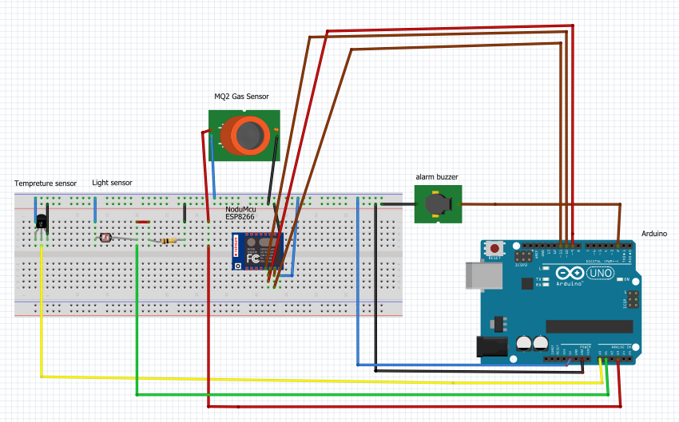

**Circuit of sensors connected with Arduino.**

**Code for Arduino:**

int Thresh = 400;

void setup() {

Serial.begin(9600);

pinMode(A0,INPUT);//temp

pinMode(A1,INPUT);//light

pinMode(A2,INPUT);

pinMode(A3,INPUT);//gas analog

pinMode(2,OUTPUT);//buzzer

pinMode(9,OUTPUT);//temp

pinMode(10,OUTPUT);//light

pinMode(11,OUTPUT);//gas analog

}

void loop() {

float temp[3];

getTemp(temp);

analogWrite(9,temp[1]);//temp

digitalWrite(10,digitalRead(A1));//light

int gas_sensor_reading = analogRead(A3);

if (gas_sensor_reading > Thresh)

{tone(2,1000,20);}

else

{noTone(2);}

analogWrite(11,gas_sensor_reading);//gas analog

Serial.print(digitalRead(A1));

Serial.print(temp[1]);

Serial.println();

}

void getTemp(float * t)

{

const int analogPin = A0; // replace 0 with analog pin

const float invBeta = 1.00 / 3380.00; // replace "Beta" with beta of thermistor

const float adcMax = 1023.00;

const float invT0 = 1.00 / 298.15; // room temp in Kelvin

int adcVal, i, numSamples = 5;

float K, C, F;

adcVal = 0;

for (i = 0; i < numSamples; i++)

{

adcVal = adcVal + analogRead(analogPin);

delay(100);

}

adcVal = adcVal / 5;

K = 1.00 / (invT0 + invBeta * (log ( adcMax / (float) adcVal - 1.00))) + 15;

C = K - 273.15; // convert to Celsius

F = ((9.0 * C) / 5.00) + 32.00; // convert to Fahrenheit

t[0] = K; t[1] = C; t[2] = F;

return;

}

**Code for NodeMcu:**

#include <ESP8266WiFi.h>

#include <FirebaseArduino.h>

#define FIREBASE_HOST "indsafe-377e6-default-rtdb.firebaseio.com"

#define FIREBASE_AUTH "W9lg4smBsD1hsxU3N4INYxlmvt2sqPX50X9Q6phS"

#define WIFI_SSID "Redmi"

#define WIFI_PASSWORD "ashu9819"

int fd=0;

float td=0.0;

int gd = 0;

void setup() {

Serial.begin(9600);

pinMode(D5,INPUT);//light

pinMode(D6,INPUT);//temp

pinMode(D7,INPUT);//gas

WiFi.begin(WIFI_SSID, WIFI_PASSWORD);

Serial.print("connecting");

while (WiFi.status() != WL_CONNECTED) {

Serial.print(".");

delay(500);

}

Serial.println();

Serial.print("connected: ");

Serial.println(WiFi.localIP());

Firebase.begin(FIREBASE_HOST, FIREBASE_AUTH);

Serial.print("connected firebase");

}

void loop() {

fd = digitalRead(D5);

Firebase.setInt("Light_value",fd);

td = analogRead(D6);

Firebase.setFloat("Temp_value",td);

gd = analogRead(D7);

Firebase.setFloat("Gas_value",gd);

Serial.println(fd);

Serial.println(td);

Serial.println(gd);

}

**RESULTS:**

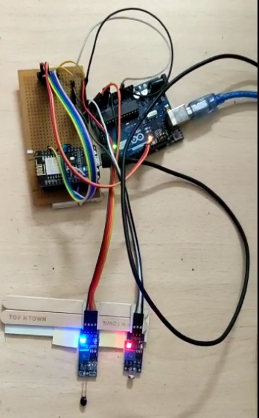 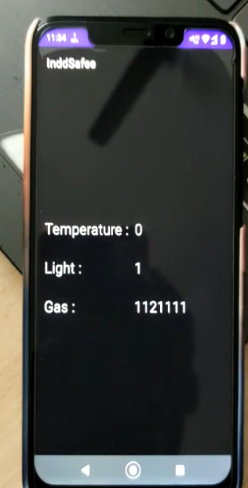

Test Setup Real Time Reading of App (LDR OFF)



Reading of firebase (LDR OFF, Light_value - 1)

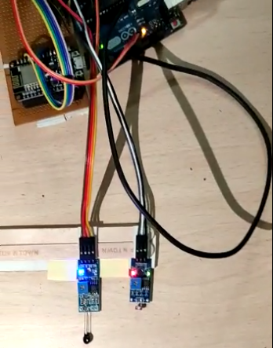 

LDR Sensor ON Reading in Firebase (LDR ON, Light_value -0)

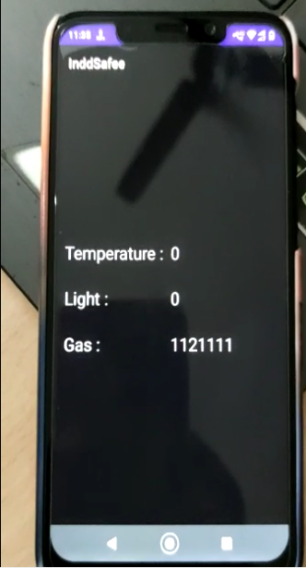

Real Time data on App

**APPLICATIONS:**

1. Electronic toll collection system.
2. Heating and air conditioning systems.
3. Home security devices.
4. Indoor Air Quality: Monitoring of toxic gas and oxygen levels inside chemical plants to ensure safety of workers and goods using different gas sensors.
5. Compost: Control of humidity and temperature levels in alfalfa, hay, straw, etc. to prevent fungus and other microbial contaminants using humidity and temperature sensors.
6. Light detection failure and control systems in industries.

**LIMITATIONS:**

1. Since the whole setup is dependent of Wi-Fi, it must always be available.
2. Maintenance of the components must be done regularly, as some components may become faulty overtime.
3. Dedicated power supply must be provided so that even if the main power goes off, the Arduino still remains functional.

**CONCLUSION AND FUTURE SCOPE**

In this project, we focused on the process of monitoring parameters like temperature, gas, light in the industries remotely with the help of Arduino and NodeMCU. The experimental setup which was designed has its focal point on monitoring few parameters. Due to advancement in technology, Wi-Fi network is easily available in all places so proposed wireless network easily controlled using any Wi-Fi network. This is a simple and portable system. This system is also platform independent allowing any web browser in any platform to connect ESP8266-01. The main objective of implementing this system is to reduce maintenance cost, improve the safety of worker as well as equipments and optimize critical monitoring systems.

This project can be further expanded along other sensors like voltage, current and energy can be used based on the requirement. Moreover, it is also possible to take further actions by controlling the actuators from the Internet once the sensor values are going above/below predetermined values.

**REFERENCES**

1. <https://components101.com/resistors/ntc-thermistor-10k>
2. <https://components101.com/sensors/mq2-gas-sensor>
3. <https://rees52.com/arduino-modules/748-lm393-optical-photosensitive-ldr-light-sensor-module-for-arduino-shield-dc-3-5v-ml026>
4. <https://www.electronicscomp.com/nodemcu-esp8266-development-board-cp2102-ic-based-india#:~:text=The%20NodeMCU%20with%20cp2102%20Wifi,the%20ESP%2D12%20SMD%20footprint>.
5. <https://www.electronicshub.org/introduction-to-industrial-automation/#:~:text=Industrial%20Automation%20is%20a%20process,the%20help%20of%20mechanized%20equipment>.
6. <https://icircuit.net/interfacing-arduino-uno-wtih-nodemcu/1474#:~:text=Please%20note%20that%20Arduino%20uno,but%20it%20is%20not%20recomended).&text=On%20nodemcu%20side%20we%20need,sent%20by%20arduino%20over%20serial>.
7. https://www.electroniclinic.com/monitor-multiple-analog-sensors-using-nodemcu-esp8266/